TM-STA-TMJ
Stakeholder Engagement

Dear Colleagues,
Your assistance in preparing TiMOTION's 2025 Sustainability Report is highly appreciated. Due to the volume of questions and multi-site data required, to streamline communication between internal teams and consultants during the data compilation phase, please adhere to the following guidelines:
 | I have read and understood.
1.Standardized Terminology for Subsidiaries: For external reporting purposes, convert internal branch codes to external names: TME>France Branch Office; TMU>United States Branch Office; TMJ >Japan Branch Office; TMA>Australia Branch Office. | 勾選
2.English Full Name Clarification: As the Report is public-facing, please provide the English full name alongside any technical abbreviation or acronym (e.g., EPR material, CRM) for reader comprehension. | 勾選
3.No Blank Fields: If no actions or statistics apply for 2025, please reply "None," "Not Applicable (N/A)," or provide a brief reason to expedite data verification. | 勾選
4.Unclear Questions: If a question cannot be answered due to unclear instructions, please respond: “Requires further explanation to answer.” All questions will be compiled by the consultants and addressed accordingly. | 勾選
5.Decimal Formatting: All numerical data should be rounded to two decimal places (e.g., 5.88, 4.20%), unless certain environmental indicators involve extremely small values—in such cases, the original figures may be provided. | 勾選
6.Expense-Related Questions: If the question involves any expenses, please provide the amount in the local currency. The headquarters will consolidate and convert all figures into New Taiwan Dollars (NTD) afterward. | 勾選

Stakeholder Communication Status
★Communication Frequency: Please categorize and detail the frequency (Monthly / Quarterly / Annually / Ad-hoc).
★Examples of Engagement Activities / Outcomes:
Suppliers
1.Communication Channels and Frequency with Stakeholders: Phone, email (irregular), supplier audits (once a year)
2.Communication / Grievance Channels: Procurement Department email: XXX@XXmail.com
3.2025 Engagement Status: Completed audits for 50 suppliers, with a 100% pass rate
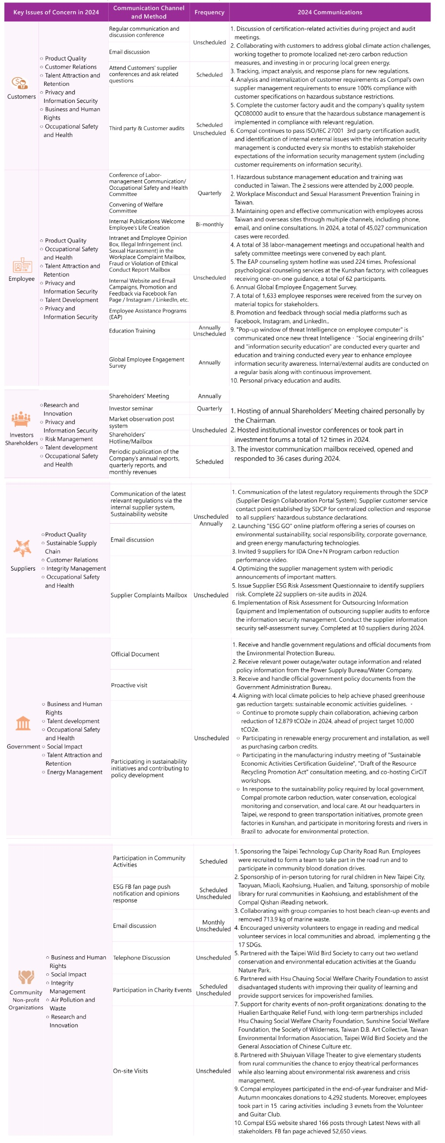
 | Communication Channels and Frequency with Stakeholders | Communication/Grievance Channels (Please specify the responsible department and contact information) | 2025 Engagement Status/Outcomes
Shareholders / Investors | N/A | N/A | N/A
Banks | Phone, email (irregular) | Accounting Section | N/A
Employees | N/A | N/A | N/A
Client | Phone, email (irregular) | Sales Section  Sales Administrative Section | N/A
Suppliers | Phone, email (irregular) | Sales Administrative Section | N/A
Government Agencies | Phone, email (irregular) | General Affairs and Human Resources Section | N/A
Local Communities | N/A | N/A | N/A

