TM-STA-TME
Stakeholder Engagement

Dear Colleagues,
Your assistance in preparing TiMOTION's 2025 Sustainability Report is highly appreciated. Due to the volume of questions and multi-site data required, to streamline communication between internal teams and consultants during the data compilation phase, please adhere to the following guidelines:
 | I have read and understood.
1.Standardized Terminology for Subsidiaries: For external reporting purposes, convert internal branch codes to external names: TME>France Branch Office; TMU>United States Branch Office; TMJ >Japan Branch Office; TMA>Australia Branch Office. | 勾選
2.English Full Name Clarification: As the Report is public-facing, please provide the English full name alongside any technical abbreviation or acronym (e.g., EPR material, CRM) for reader comprehension. | 勾選
3.No Blank Fields: If no actions or statistics apply for 2025, please reply "None," "Not Applicable (N/A)," or provide a brief reason to expedite data verification. | 勾選
4.Unclear Questions: If a question cannot be answered due to unclear instructions, please respond: “Requires further explanation to answer.” All questions will be compiled by the consultants and addressed accordingly. | 勾選
5.Decimal Formatting: All numerical data should be rounded to two decimal places (e.g., 5.88, 4.20%), unless certain environmental indicators involve extremely small values—in such cases, the original figures may be provided. | 勾選
6.Expense-Related Questions: If the question involves any expenses, please provide the amount in the local currency. The headquarters will consolidate and convert all figures into New Taiwan Dollars (NTD) afterward. | 勾選

Stakeholder Communication Status
★Communication Frequency: Please categorize and detail the frequency (Monthly / Quarterly / Annually / Ad-hoc).
★Examples of Engagement Activities / Outcomes:
Suppliers
1.Communication Channels and Frequency with Stakeholders: Phone, email (irregular), supplier audits (once a year)
2.Communication / Grievance Channels: Procurement Department email: XXX@XXmail.com
3.2025 Engagement Status: Completed audits for 50 suppliers, with a 100% pass rate
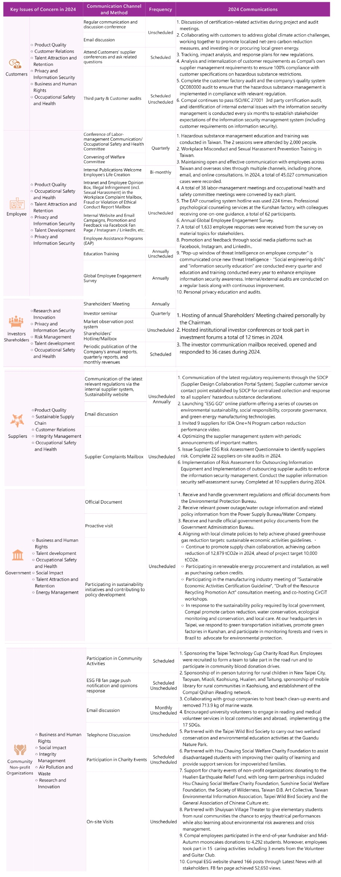
 | Communication Channels and Frequency with Stakeholders | Communication/Grievance Channels (Please specify the responsible department and contact information) | 2025 Engagement Status/Outcomes
Shareholders / Investors | Emails, Teams, Phone  Ad-hoc + Annual review | Directors  rich.wang@timotion.com  nicolas.martin@timotion.com | Annual Management Review with actions plan
Banks | Emails + Phone  Ad-hoc | Finance department + Director:  celine.guenee@timotion.com  nicolas.martin@timotion.com | Received circularization letters from banks  Operations problems solved when required
Employees | Emails, Teams, Phone, Direct contact  Daily | HR department  clement.ferretti@timotion.com | Not sure what to answer here as there are many types of communications towards employees.
Client | Emails, Teams, Phone, Direct contact  Daily | Sales team mainly  We have many contacts here, all people from Sales team | Maintain Customer base + growth
Suppliers | Emails, Teams, Phone  Daily | Related department - depends on the purchase | Review Supplier status annualy according to our ISO process
Government Agencies | Emails, letters  Ad-hoc | Finance and Administration department depending on the topic  Celine.guenee@timotion.com  anne.dekker@timotion.com  nicolas.martin@timotion.com | Completes legal local requirements and declarations
Local Communities | Emails, letters  Ad-hoc | Finance and Administration department depending on the topic  Celine.guenee@timotion.com  anne.dekker@timotion.com  nicolas.martin@timotion.com | Completes legal local requirements and declarations

