TM-ENV-TMJ
Introduction

Dear Colleagues,
Your assistance in preparing TiMOTION's 2025 Sustainability Report is highly appreciated. Due to the volume of questions and multi-site data required, to streamline communication between internal teams and consultants during the data compilation phase, please adhere to the following guidelines:
 | I have read and understood.
1.Standardized Terminology for Subsidiaries: For external reporting purposes, convert internal branch codes to external names: TME>France Branch Office; TMU>United States Branch Office; TMJ >Japan Branch Office; TMA>Australia Branch Office. | 勾選
2.English Full Name Clarification: As the Report is public-facing, please provide the English full name alongside any technical abbreviation or acronym (e.g., EPR material, CRM) for reader comprehension. | 勾選
3.No Blank Fields: If no actions or statistics apply for 2025, please reply "None," "Not Applicable (N/A)," or provide a brief reason to expedite data verification. | 勾選
4.Unclear Questions: If a question cannot be answered due to unclear instructions, please respond: “Requires further explanation to answer.” All questions will be compiled by the consultants and addressed accordingly. | 勾選
5.Decimal Formatting: All numerical data should be rounded to two decimal places (e.g., 5.88, 4.20%), unless certain environmental indicators involve extremely small values—in such cases, the original figures may be provided. | 勾選
6.Expense-Related Questions: If the question involves any expenses, please provide the amount in the local currency. The headquarters will consolidate and convert all figures into New Taiwan Dollars (NTD) afterward. | 勾選

CH 5.3 Water Resource Management

CH 5.3 Water Resource Management

Water management policy, assessment mechanisms, and actions (GRI 303-1)
Reference example:
ABC Company follows the ISO 46001 Water Resource Management System and has established a comprehensive management framework, including water management, risk analysis, target setting, and continuous water-saving measures, at the same time, the company collaborates with suppliers to jointly develop water-saving technologies and water recycling systems to reduce water withdrawal. It has also established an emergency water truck supply chain, conducting annual transportation drills to ensure a stable water supply for operations and production lines. ABC Company proactively deploys water scarcity risk management, monitors reservoir storage levels across regions, and conducts comprehensive reviews of water-saving measures using water balance charts. The company has also established a “Water Resource Emergency Response Team”, to inventory local water sources and water truck capacity. When water withdrawal pressure exceeds the six month average, the company initiates a 5% voluntary water reduction. If the withdrawal pressure persists for one month without relief, the voluntary reduction rate is further increased to 7%. In addition, the company utilizes an intelligent water recycling management system to dynamically allocate recycled water for internal use, thereby improving water use efficiency
答案：N/A

a. Please describe your company’s approach to water management and its energy consumption
b. Does the company have external assurance (methods and frequency) and internal audits (methods and frequency) related to water and energy management?
c. Are there any water efficiency measures Please explain the implementation details and the results achieved.
Reference example:
Under the impact of global extreme climate, water resources are increasingly scarce, and many regions face drought risks. ABC Company applied the WRI’s water risk assessment tool to analyze Taiwan’s water resource situation, showing that it is currently in a low-risk range. Earlier, we implemented various water efficiency strategies and measures, ranging from employees’ daily water use to equipment water recycling and reuse, all of which have shown positive results. To further enhance water recycling, in 2022 we established a water recycling rate R2 (excluding cooling tower circulation) as a key annual management indicator, enabling us to monitor water use status, evaluate the effectiveness of water-saving and reuse programs, and conduct reviews and analysis.
答案：N/A

Does the company conduct water-related risk assessments (e.g., water shortage risk assessment) and establish response measures? If yes, please describe the assessment process, frequency, scope, identified risk categories, and explain the impacts on the company and the corresponding response measures.
答案：N/A

In 2025, has the company incurred any significant fines or non-monetary sanctions due to non-compliance with water-related laws and/or regulations? Please disclose the total monetary value of significant fines, the number of non-monetary sanctions, and any legal cases. If applicable, explain the nature of the non-compliance and the corrective actions taken.
答案：N/A

CH 5.4 Waste management

CH 5.4 Waste management

Statistics on the classification of waste generated directs to disposal
Unit: metric tons
 | Year 2023 | Year 2024 | Year 2025 | Note
Sale of industrial waste
General industrial bulky solid waste
Hazardous waste
Food waste
household waste
Total solid waste generated

Please describe your company’s waste generation and waste management practices
2024 Report Content:
Dongguan TiMOTION strictly implements waste categorize, collection, and management. Different categories of waste are stored in separate warehouses with proper packaging. Part of the waste is recycled internally, while the remainder is handed over to qualified external contractors for transportation and treatment.
Main types of waste include:
◆Recyclable industrial waste, such as packaging materials, metal scraps, and plastics generated during production, part of this waste can be recycled internally after simple treatment for reuse within the facility. The portion of waste that cannot be reused internally is collected and transported by treatment agencies to further detailed sorting
◆ according to different materials delivered to downstream processors to reprocess the materials according to their type into products with certain economic value.
◆ Industrial waste and household waste without recycling value are handed over to treatment agencies, generally for landfill or incineration.
◆Food waste is processed by specialized contractors, who can produce biogas or convert it into animal feed and other products.
◆During the production process, hazardous waste is generated, such as used cutting fluids, oil-contaminated rags and containers, sludge, and spent activated carbon. The company strictly complies with environmental requirements and entrusts certified professional agencies for treatment.

In 2025, has the company incurred any significant fines or non-monetary sanctions due to violations of waste-related laws and/or regulations?
Please disclose the total amount of significant fines, the number of non-monetary sanctions, and any litigation cases. If applicable, explain the nature of the violation and subsequent corrective actions.
答案：N/A

CH 5.5 Energy efficiency and carbon reduction measures

CH 5.5 Energy efficiency and carbon reduction measures

a. Please describe your company’s energy management approach
b. Explain the company’s energy consumption status.
c. Indicate whether there are external audits (methods and frequency) and internal audits (methods and frequency) related to energy management.
d. Describe any energy-saving measures, including implementation details and results

Please disclose the total energy consumption in 2025 at your site, and specify the main sources of energy used (e.g., electricity, gasoline, diesel, liquefied petroleum gas, natural gas)
(GRI 302-1)
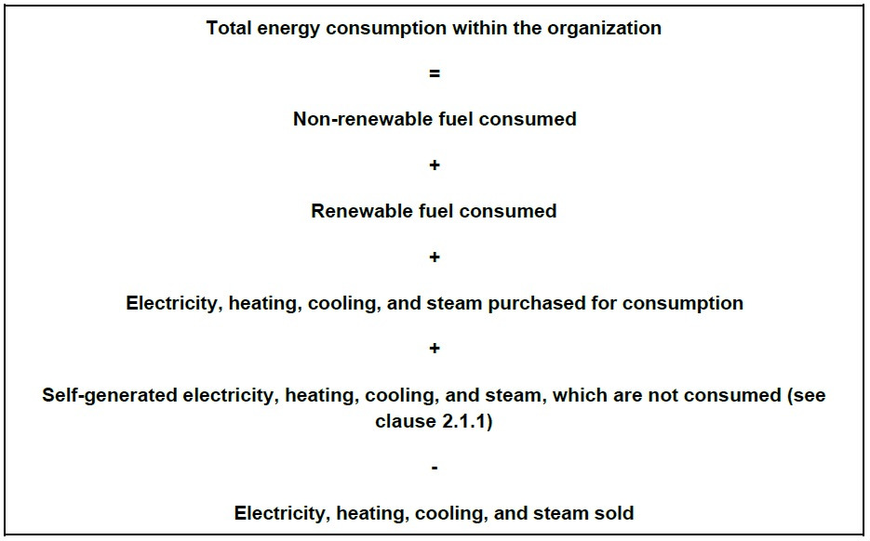

Energy consumption statistics for the past three years (GRI 302-1)
Unit: GJ
 | Year 2023 | Year 2024 | Year 2025 | Main sources of emissions and explanation
Electricity
Steam
Natural gas
Diesel
Gasoline
Liquefied petroleum gas
Total

Energy consumption outside of the organization (GRI 302-2)
Unit: GJ
The organization can use the following upstream and downstream categories and activities
from the ‘GHG Protocol Corporate Value Chain (Scope 3) Accounting and Reporting Standard’
for identifying relevant energy consumption outside of the organization.
Upstream categories
1. Purchased goods and services
2. Capital goods
3. Fuel- and energy-related activities (not included in Disclosure 302-1)
4. Upstream transportation and distribution
5. Waste generated in operations
6. Business travel
7. Employee commuting
8. Upstream leased assets
Other upstream
Downstream categories
1. Downstream transportation and distribution
2. Processing of sold products
3. Use of sold products
4. End-of-life treatment of sold products
5. Downstream leased assets
6. Franchises
7. Investments
Other downstream
For each of these categories and activities, the organization can calculate or estimate the
amount of energy consumed.
The organization can report energy consumption separately for non-renewable sources and
renewable sources.
 | Year 2023 | Year 2024 | Year 2025 | Explanation of changes and management approach
Energy consumption (GJ)

Energy-saving achievements : Does your company have additional energy-saving measures? If yes, please describe the implementation methods and disclose the amount of energy saved, (expressed in gigajoules (GJ).

In 2025, has the company incurred any significant fines or non-monetary sanctions due to violations of energy-use related laws and/or regulations? Please disclose the total amount of significant fines, the number of non-monetary sanctions, and any litigation cases. If applicable, explain the nature of the violation and subsequent corrective actions.
答案：N/A

a. Please describe your company's philosophy regarding greenhouse gas (GHG) management and the status of the carbon inventory.
b. Are there external audits (method and frequency) and internal audits (method and frequency)?
c. Does the company have carbon reduction measures? If so, please describe the implementation content and outcomes.
答案：N/A

Greenhouse Gas (GHG) Emissions by Site (GRI 305-1，305-2)
 | Year 2024 | Year 2025
Scope 1 Direct Greenhouse Gas Emissions
Scope 2 Energy indirect GHG emissions
Total

Energy efficiency and Carbon Reduction Projects in 2025
 | Project 1 | Project 2
Project Title
Project content
Resources (manpower, budget)
Project duration
Project duration

Energy efficiency and Carbon Reduction Outcomes in 2025 (GRI 302-4)(GRI 305-5)
Year 2025
Energy efficiency and Carbon Reduction Measures
Electricity Savings (Thousand kWh)
Carbon Emissions Reduction (tCO2e)
Energy Savings (GJ)

Has the company implemented "Energy and Carbon Reduction Measures for Electricity Use"? If yes, please describe the relevant measures and the energy efficiency and carbon reduction benefits.

Has the company conducted an energy inventory? When was it completed (within the past year, within the past two years, or more than three years ago)?

CH 5.6 TCFD Climate change mitigation and adaptation

CH 5.6 TCFD Climate change mitigation and adaptation

[Risk Management] Physical risks (acute: typhoons, floods, heatwaves; chronic: sea level rise, increased hot days) — How often are these risks assessed? What are the early warning mechanisms (e.g., geographic coordinates, critical infrastructure, supply and logistics nodes)?
答案：Physical climate-related risks (acute and chronic) are assessed on a regular basis using disaster prevention maps and manuals issued by local Japanese authorities. These materials provide location-specific risk information based on geographic conditions and are updated when revised by the authorities.
Early warning mechanisms rely on official hazard maps, public meteorological alerts, and local government disaster guidance, which support employee preparedness, evacuation planning, and emergency response.

