PT2023-PEC-TW-Community-20231011
GRI 413 社會參與

社區參與 (GRI 413-1)
請說明貴公司之社區參與政策或承諾 (GRI 3-3)
範例：
本公司每年為協助弱勢群體，針對節慶員工福利禮盒，採取與社福團體合作之方式，購置社福機構組公益禮盒作為員工禮盒，以實際行動支持弱勢群體。此外OO亦捐助湖口鄉公所急難救助金，並提供天下刊物予廠區附近中小學兒童閱讀，鼓勵學童認真學習。

請同仁以各部門/ESG環節思考，2023年公司對於環境，經濟，社會(人/人權)造成哪些正/負面的影響? 正面的意思: 有正面實質或潛在貢獻，例如促進經濟成長，提供員工生計，製造創新產品促進人類文明發展等；負面的意思：造成汙染、破壞自然景觀等。
社會議題 | 權慣單位 | 正面衝擊(對於環境、經濟、社會/人):肯定與殊榮 | 負面衝擊(對於環境、經濟、社會/人):違失事項:

2023年永續成果速覽

社會議題衝擊評估的結果 (由JYG顧問彙整填寫)

外部協會組織參與 (GRI 2-28)
請說明貴公司公司 2023 年參與哪些外部協會組織
2023年OO持續參與新竹工業區廠商協進會、新竹工業會外部公協會、社團法人台灣電池協會及財團法人人力資源管理協會，皆為一般會員。

呈上，請填寫以下表格：
參與公協會 | 參與人員 | 參與方式 | 主要目的

外部組織倡議支持
公司支持國內外組織在經濟、環境與社會規章/原則或其他倡議與目的，如下：
外部倡議 | 參與之目的 | 參與人員 | 參與方式

社會影響力
請提供公益活動參與人員、參與方式和主要影響力(有多項活動，請複製此表格)
初衷 (Why) | 權責單位 (Who) | 合作單位 | 行動 (What) | 產生效益說明

請提供活動照片

CSA 3.6.1 Corporate Citizenship Strategy

Does your company have a group-wide strategy that provides guidance to your corporate citizenship/ philanthropic activities? Please indicate how this strategy aligns with your overall corporate strategy and the 17 UN Sustainable Development Goals.
Please specify and provide supporting documents:
Priorities & KPIs
- Please indicate the three main voluntary or charitable priorities as outlined in your group-wide corporate citizenship/philanthropy strategy specified above and whether the priority is publicly available.
- For each priority, please indicate which UN Sustainable Development Goal the priority is aligned with. Furthermore, please provide a short description of how the priority is aligned with your business drivers. In addition, please indicate which KPIs your company uses to measure the benefits of the three main priorities.
- The KPIs need to be measurable and you should provide quantitative results wherever possible. Please clearly describe the benefit KPIs as well as the activity in the provided text boxes.
Below is an example from the HQ
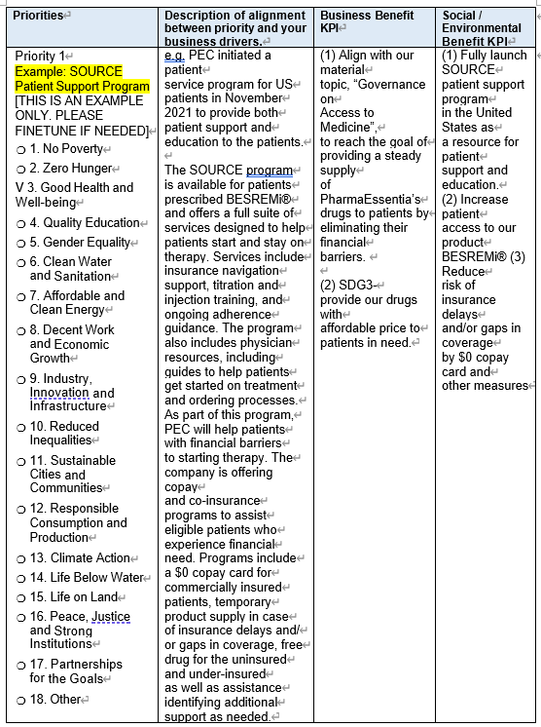
Priorities | Description of alignment between priority and your business drivers. | Business Benefit KPI | Social / Environmental Benefit KPI

Please provide ONE examples from the JP team which focus on (A) R&D innovation
 | Description of alignment between priority and your business drivers. | Business Benefit KPI | Social / Environmental Benefit KPI

Please provide supporting document:

Please provide ONE examples from the JP team which focus on (B) Quality drugs
 | Description of alignment between priority and your business drivers. | Business Benefit KPI | Social / Environmental Benefit KPI

Please provide supporting document:

Please provide ONE examples from the JP team which focus on (C) Access to Medicine
 | Description of alignment between priority and your business drivers. | Business Benefit KPI | Social / Environmental Benefit KPI

Please provide supporting document:

CSA 3.6.2 Type of Philanthropic Activities

For the last fiscal year (2022), please indicate on a consolidated group-wide basis what percentage of your corporate citizenship and/or philanthropic contributions falls within each category. Please refer to the information button for definitions and explanations of the categories.
 | Type or Name of activities | Please describe your contribution (e.g. intangible or tangible)

Please provide supporting document:

CSA 3.6.3 Philanthropic Contributions

Philanthropic Contributions
For the last fiscal year, please estimate the total monetary value (at cost) of your company's corporate citizenship/philanthropic contributions for each of the following categories. Please note that marketing and advertising budgets should be excluded from the calculation.
Type of Contribution
 | Total Value (USD) | Percentage of Total Costs (%)

Please provide supporting document:

