PJ023-PEC-JP-Finance-20231011
GRI 207 Tax

Tax Strategy and Governance (GRI 207-1, GRI 207-2, GRI 207-3, GRI 207-4)
Please explain company's tax policy and describe the tax governance and control framework. (GRI 207-1, GRI 207-2)
Example from previous year:
Our company's tax management unit is coordinated and managed by the accounting departments of PharmaEssentia
Headquarters and subsidiaries. If there are any important decisions, professional tax consultants may be consulted or appointed
according to the situation. We strictly comply with the commercial laws and tax regulations of Taiwan and the local
jurisdictions where we operate, and is transparent in disclosing information in accordance with regulations to strengthen
the group's compliance with tax laws and commitment to fulfill its corporate social responsibility. We are committed to the
following tax management policy to reduce tax risks, optimize post-tax operating results, and protect shareholder interests.

Please explain how your company communicates its tax issues with stakeholders. (GRI 207-3)
Please refer to example from previous year.
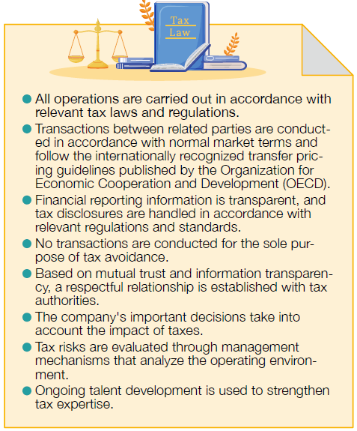

Please fill out the following table regarding tax jurisdiction disclosures (GRI 207-4).
Please provide information

Please provide supporting documents.

CSA 1.8.1 Tax Strategy and Governance

Please select which of the following does your company’s tax policy, strategy or principles cover:
Our tax policy covers the following:
答案：

Other, please specify

Please provide supporting document:

Does your company have a publicly available and group-wide tax policy, strategy or principles in place which
indicate your approach towards taxation?

If yes, Please provide the relevant web link:
✓ A commitment to compliance with the spirit as well as the letter of the tax laws and regulations in the
countries in which the company operates
✓ A commitment not to transfer value created to low tax jurisdictions
✓ A commitment not to use tax structures without commercial substance
✓ A commitment to undertake transfer pricing using the arm’s length principle
✓ A commitment not to use secrecy jurisdictions or so-called "tax havens” for tax avoidance
✓ An approval process of the tax policy by the board of directors

If not applicable. Please provide explanations in the comment box below.

CSA 1.8.2 Tax Reporting

Please indicate the following tax related metrics on a tax jurisdiction basis:
Please fill in the following answers:
答案：

Please provide supporting document:

Does your company publicly report on key business, financial and tax information for each tax jurisdiction where the entities included in your organization’s audited consolidated financial statements are resident for tax purposes?
Please indicate where this information is available in your public reporting
答案：

If yes, please select which of the following you have provided and indicate where this information is available in your public reporting.
Please indicate where this information is available in your public reporting
Names of all the resident entities | Primary activities | Number of employees | Revenue | Profit (Loss) before tax
Income tax accrued (current year) | Income tax paid

If not applicable. Please provide explanations in the comment box below.

CSA 1.8.3 Effective Tax Rate

Please complete the following table related to your reported tax rate (income statement) and cash tax rate (cash flow statement) for the last two years.
Additionally, please select (if necessary) why the reported tax rate and/or the cash tax rate might be lower than expected.
Currency: TWD - New Taiwan Dollar
Listed companies are required to provide links to public reports or corporate websites.
Non-Listed companies may provide internal documents and/or links to public reports or corporatewebsites.
Single jurisdiction tax code (maximum 10% sales abroad and domestic corporate income tax rate below the posted industry group average)
2023新增以下
If the calculated average tax rate and/or cash tax rate is lower than the industry group averages shared via the information text, please specify the reason why, indicate the tax amount per item and provide explanations in the table below.
Please also indicate where this information is available in your reporting or corporate website
 | FY 2020 | FY 2021 | FY 2022 | FY 2023 (available after 2024) | Calculated Average Rate

Please specify the reason why and indicate where this information is available in your reporting or corporate website

If the aspect reduced your tax burden (tax benefit), please indicate the impact as a negative number,
however if the aspect increased your tax burden (tax expense), please indicate the impact as a positive
number.
On the basis of the numbers inputted, you will see an autocalculation of the rate above: please
double-check that figure to ensure you have reported these aspects with the correct sign.
Listed companies are required to provide links to public reports or corporate websites.
Non-Listed companies may provide internal documents and/or links public reports or corporate websites
 | Tax Impact FY 2020 | Tax Impact FY 2021 | Tax Impact FY 2022 | Tax Impact FY 2023 (available after 2024) | Explanation

If it's not applicable. Please provide explanations in the comment box below

Please provide supporting document:

(TCFD) Climate-Related Risks and Opportunities Financial Impact Assessment

Climate-Related Information for Listed Companies
Please describe the Risks and Opportunities related to Climate Change and Relevant Mitigation Measures Taken by the Company
Example from previous year:
Climate change is a challenge faced by the entire world today. We are actively planning
various climate actions, hoping that the implementation of internal operational strategies
can help us be in line with world standards, move towards SDG13-Climate Action, and
work with others to exert PharmaEssentia’s influence and strive to mitigate climate change.
In 2022, under the TCFD framework, we prioritized climate-related physical and transitional
risk and opportunity identification as well as the GHG Inventories of our plants. In the
future, we will continue to conduct scenario and quantitative financial impact analysis on
major risk and opportunity projects, provide stakeholders with relevant and reliable financial
measurement information, and work with others to help maintain the sustainable development
of the environment.

Climate-Related Information for Listed Companies
(Select one answer option per line)
 | Already Planned | Planning in Progress | Not Yet Planned | Pleasse provide more information on the answer you have provided.

Please provide information your company's greenhouse gas (GHG) inventory and verification status.
The company has conducted GHG inventories assessments according to the following standards:
答案：

Please provide information on the company's authorized capital. (USD)

Please explain the scope of disclosures required by the Sustainability Development Roadmap for listed companies.
 | Is this in the disclosure? | Please provide more information

Please provide more information on the company's total GHG emissions and intensity for the year 2023.
(Unit: metric tons)
 | Total Emissions (metric tons CO2e) | Intensity (metric tons CO2e per million dollars) | Assurance Provider (entity) | Description of Assurance Status

Please provide supporting documents.

