PJ2023-PEC-JP-GMOffice
CSA 1.1 Board Structure

Board Type: Please select whether your company has a one-tier or two-tier board and provide a reference:
ONE-TIER SYSTEM (companies with a board of directors)
Please indicate the number of executive and non-executive directors on the board of directors/supervisory board of your company and specify where this information is available. In addition, please indicate if your company has an independence statement for its board of directors in place. Additional clarification on one-tier and two-tier systems is available in the information text
Listed companies are required to provide links to public reports or corporate websites.
Non-Listed companies may provide internal documents and/or links to public reports or corporate websites.
Number of members

TWO-TIER SYSTEM (companies with a supervisory board)
SUPERVISORY BOARD
Number of members

TWO-TIER SYSTEM (companies with a supervisory board)
MANAGEMENT BOARD/ EXECUTIVE MANAGEMENT
Number of members

TWO-TIER SYSTEM (companies with a supervisory board)
SUPERVISORY BOARD & MANAGEMENT BOARD/ EXECUTIVE MANAGEMENT
Number of members

Board Independence Statement
Please indicate if your company has an independence statement for the board of directors in place.
We have an independence statement. Please indicate below what the statement includes and provide a reference.
答案：
An explicit definition of what determines that a board member is independent. Please specify:
答案：
A target share of independent directors on the board. Please specify: ➢ We do not have an independence statement that meets the disclosure requirements of this question for listed/non-listed companies.
答案：

Please specify explicit definition of what determines that a board member is independent.

Listed companies are required to provide links to public reports or corporate websites. Provide URL below:

Please provide supporting document:

CSA 1.1.2 Non-Executive Chairperson/ Lead Director

Is the board of directors/supervisory board headed by a non-executive and independent chairperson and/or an independent lead director?

Role of chairperson and CEO is joint, but independent lead director is appointed. Please indicate the name of the lead director:

Please provide supporting document:

CSA 1.1.3 Board Diversity Policy

Does your company have a formal board diversity policy that clearly requires diversity factors such as gender, race, ethnicity, country of origin, nationality, or cultural background in the board nomination process?

Yes, our policy specifically includes the following:
答案：

CSA 1.1.4 Board Gender Diversity

Please indicate the number of women on your company's board of directors/supervisory board. If your company has a one-tier board structure, this figure includes: female executive directors, non-executive directors and independent directors. If your company has a two-tier board structure, this figure ONLY includes female independent directors and non-executive directors (this means that senior executives and employee representatives should not be included).
Number of female directors:

Please provide supporting document:

CSA 1.1.5 Board Effectiveness

How does your company ensure the effectiveness of your board of directors / supervisory board and the alignment with the (long-term) interests of shareholders?
Indicators/measures

Please provide supporting document:

CSA 1.1.6 Board Average Tenure

Please indicate the average tenure of board members on your company’s board of directors/supervisory board in years. If your company has a one-tier board structure, this figure includes all members (executive directors, non-executive directors and independent directors). If your company has a two-tier board structure, this figure ONLY includes independent directors and non-executive directors (e.g. exclude employee representatives).
Average tenure of board members in years:

Please provide supporting document:

CSA 1.1.7 Board Industry Experience

Please indicate the number of board members with relevant work experience in your company's sector according to GICS Level 1 sector classification (excluding executive members and employee representatives) and list the directors' names.
Number of independent or non-executive members with industry experience (e.g., excludes executives):

Please list the independent or non-executive directors included in the above count:

Please provide supporting document:

CSA 1.1.10 Management Ownership

Do your company's CEO and other executive committee members hold company shares? Please note that the shares included in the calculation should not be hedged or the personal financial risk of holding the shares otherwise removed.

Please fill in below
 | Name(s) | Multiple of base salary

CSA 1.1.11 Management Ownership Requirements

Does your company have specific stock ownership requirements for the CEO and other members of your executive committee?

If Yes, please indicate at which levels this exist and indicate the share ownership requirements as a multiple of the annual base salary.
答案：

Please provide supporting document:

CSA 1.1.12 Government Ownership

Please indicate whether individual governmental institutions own more than 5% of the total voting rights of your company and if yes, whether golden shares exist for them. Government ownership of 5% or less of the voting rights need not be reported.

If Yes, please provide the total percentage of government ownership (sum of % of individual governmental institutions owning more than 5% of voting rights):

If Yes, please provide details for the government ownership (e.g. calculation, members, organizations etc. if available):

Golden Shares for Governmental Institutions
Does your company have golden shares for governmental institutions?

Please provide supporting document:

CSA 1.3.1 Risk Governance

Please indicate which people, departments and committees are responsible and accountable for enterprise risk management in terms of risk appetite & tolerance as well as risk monitoring & reporting. Please also indicate the expertise and training applicable to non-executive directors as well as the corporate structure of risk management functions.
 | Please indicate name and position | Reporting line: please indicate who the person or committee reports to.

CSA 1.3.4 Risk Culture

What strategies does your company pursue in order to promote and enhance an effective risk culture throughout the organization? Please indicate the relevant options below, specify where prompted and provide supporting evidence.
答案：

Financial incentives which incorporate risk management metrics, please specify the incentives and metrics and provide supporting evidence.
 | Incentives | Metrics

Please provide supporting document:

CSA 1.5.1 Contributions & Other Spending

Please indicate your annual total monetary contributions to and spending for political campaigns, political organizations, lobbyists or lobbying organizations, trade associations and other tax-exempt groups, as defined in the Info Text.

We are able to itemize the figures. If you have not made any contributions for one or more items, please enter 0.
 | Currency | FY 2020 | FY 2021 | FY 2022 | FY 2023 YTD

We can only report the total spending figures. Please indicate the items included in your total spending figures. If an item is not included, please select "not included". If you have not made any contributions for a specific category, please select "No contribution."
Lobbying, interest representation or similar
答案：
Local, regional or national political campaigns / candidates
答案：
Trade associations or tax-exempt groups (e.g. think tanks)
答案：

Please indicate the total spending for items included above.
 | Currency | FY 2020 | FY 2021 | FY 2022 | FY 2023 YTD

Please provide supporting document:

CSA 1.5.2 Largest Contributions & Expenditures

Did your company make any contributions to or expenditures to political campaigns or organizations, lobbying, trade associations, tax-exempt entities, or other groups whose role is to influence political campaigns or public policy and legislation? In this context, a “contribution” is the aggregate amount given during the fiscal period to an individual candidate, organization, ballot measure, or “issue area” or “topic” requiring lobbying efforts.

Yes, we made contributions.
Please provide information on the Issue or Topic you are contributing towards:
(Currency: USD)
Please enter corresponding number (1-5) under Corporate Position column:
1) Support
2) Support with minor exceptions
3) Support with major exceptions
4) Oppose
5) No contribution
Name of Issue / Topic | Corporate Position | Description of Position / Engagement | Total spend in FY 2020 | Total spend in FY 2021
Total spend in FY 2022

Other Large Expenditures (USD)
Please enter one of the following for Type of Organization
❍ National political organization
❍ State or local political campaign, candidates or committees
❍ Political Action Committee (PAC)
❍ Lobbying, interest representation or similar
❍ Trade association
❍ Tax-exempt group
❍ No contribution
❍ Other: please specify type
Name of organization, candidate or topic | Type of Organization | Total amount paid in FY 2020 | Total amount paid in FY 2021 | Total amount paid in FY 2022

Please provide supporting document:

CSA 2.2.1 Environmental Policy & Commitments

Which of your company’s public environmental policy covers the following elements of an Environmental Management System?
答案：

Commitment and oversight to implementation of environmental management policy and/or improving environmental performance. Please select the highest committing decision-making body:

Roles and responsibilities for implementing environmental management policy (please check all that applies)
答案：

Please provide supporting document:

CSA 2.2.2 Coverage of Environmental Management Policy

Which parts of your operations, corporate processes and supply chain are covered by your environmental policy?
Our public environmental policy covers the following:
答案：

Other, please specify:

Please provide supporting document:

CSA 2.3.3 Energy Consumption

Please complete the following table about total energy consumption. For each row in the table, it is mandatory that the values provided are in the same unit.
Boundary: PEC Japan office (Units: GHG in Metric tons; energy in MWh)
 | FY 2020 | FY 2021 | FY 2022 | 2023 YTD | What was your target for FY 2022?

Please provide supporting document:

CSA 2.3.4 Water Consumption

Please provide your company's total net fresh water consumption, including data for fresh water extraction and consumption. For each row in the table, it is mandatory that the values are provided in the same unit.
Boundary: PEC Japan office (Units: Million cubic meters)
 | FY 2020 | FY 2021 | FY 2022 | 2023 YTD | What was your target for FY 2022?

Please provide supporting document:

CSA 3.6.1 Corporate Citizenship Strategy

Does your company have a group-wide strategy that provides guidance to your corporate citizenship/ philanthropic activities? Please indicate how this strategy aligns with your overall corporate strategy and the 17 UN Sustainable Development Goals.
Please specify and provide supporting documents:
Priorities & KPIs
- Please indicate the three main voluntary or charitable priorities as outlined in your group-wide corporate citizenship/philanthropy strategy specified above and whether the priority is publicly available.
- For each priority, please indicate which UN Sustainable Development Goal the priority is aligned with. Furthermore, please provide a short description of how the priority is aligned with your business drivers. In addition, please indicate which KPIs your company uses to measure the benefits of the three main priorities.
- The KPIs need to be measurable and you should provide quantitative results wherever possible. Please clearly describe the benefit KPIs as well as the activity in the provided text boxes.
Below is an example from the HQ
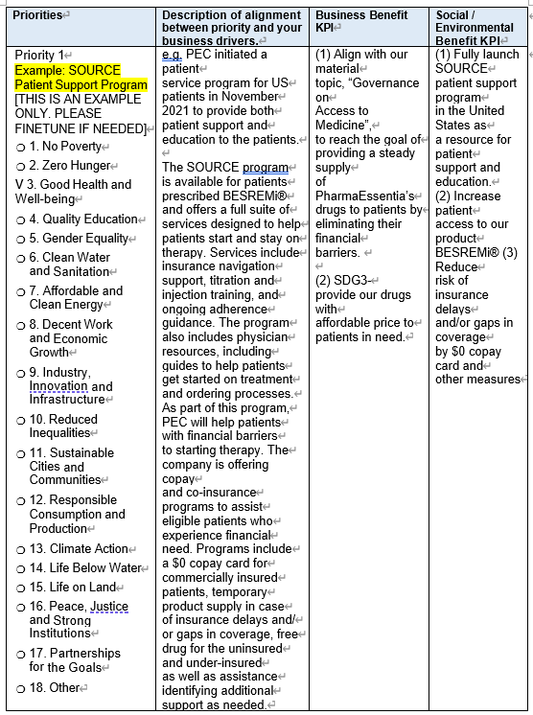
Priorities | Description of alignment between priority and your business drivers. | Business Benefit KPI | Social / Environmental Benefit KPI

Please provide ONE examples from the JP team which focus on (A) R&D innovation
 | Description of alignment between priority and your business drivers. | Business Benefit KPI | Social / Environmental Benefit KPI

Please provide supporting document:

Please provide ONE examples from the JP team which focus on (B) Quality drugs
 | Description of alignment between priority and your business drivers. | Business Benefit KPI | Social / Environmental Benefit KPI

Please provide supporting document:

Please provide ONE examples from the JP team which focus on (C) Access to Medicine
 | Description of alignment between priority and your business drivers. | Business Benefit KPI | Social / Environmental Benefit KPI

Please provide supporting document:

CSA 3.6.2 Type of Philanthropic Activities

For the last fiscal year (2022), please indicate on a consolidated group-wide basis what percentage of your corporate citizenship and/or philanthropic contributions falls within each category. Please refer to the information button for definitions and explanations of the categories.
 | Type or Name of activities | Please describe your contribution (e.g. intangible or tangible)

Please provide supporting document:

CSA 3.6.3 Philanthropic Contributions

